Photos and videos
View photos and videos
The Photos app lets you view the photos and videos:
•Taken with Camera on iPad
•Stored in iCloud (see iCloud Photo Library
•Shared from others (see iCloud Photo Sharing
•Synced from your computer (see Sync with iTunes
•Saved from an email, text message, webpage, or screenshot
•Imported from your camera

The Photos app includes tabs for Photos, Shared, and Albums.
•Tap Photos to see all your photos and videos, organized by Years, Collections, and Moments. To
quickly browse the photos in a collection or year, touch and hold for a moment, then drag.
•Tap Shared to see photos and videos you shared with others or that others shared with you.
See iCloud Photo Sharing
•Tap Albums to see how photos and videos are organized into albums on your iPad.

View all your photos and videos.
By default, Photos displays a representative subset of your photos when you view by year or by collection. To see all your photos, go to Settings > Photos & Camera, then turn off Summarize Photos.

Search photos.
From Albums or Photos, tap to search by date (month and year), or place

(city and state). Search also keeps your Recent Searches on hand and gives you a list of suggested searches

Play a slideshow.
While viewing a album tap Slideshow. Select options, then tap Start Slideshow. To stop the slideshow, tap the screen. To set other slideshow options, go to Settings > Photos & Camera

Create a new album. Tap Albums, tap +, enter a name, then tap Save. Select photos and videos
to add to the album, then tap Done.
Add items to an existing album.
While viewing thumbnails, tap Select, select items, tap Add To, then select the album.
Manage albums.
While viewing your album list, tap Edit.
•Rename an album: Select the album, then enter a new name.
•Rearrange albums: Touch, then drag the album to another location

Delete an album: Tap

My Photo Stream
My Photo Stream, turned on by default, automatically uploads new photos and videos to your
other devices that use My Photo Stream. Turn My Photo Stream on or off. Go to Settings
> Photos & Camera, or Settings > iCloud > Photos.
Note:Photos stored in iCloud count against your total iCloud storage, but photos uploaded to
My Photo Stream don’t count additionally against your iCloud storage

Ways to share photos and videos
You can share photos and videos in Mail or Messages, or through other apps you install.
Share or copy a photo or video. View a photo or video, then tap . If you don’t see , tap the
screen to show the controls.
Tap More in Sharing to turn on the apps you want to use for sharing.

The size limit of attachments is determined by your service provider. iPad may compress photo
and video attachments, if necessary.
You can also copy a photo or video, then paste it into an email or text message (MMS or
iMessage).

Edit photos and trim videos
You can edit photos right on iPad. If your photos are stored in iCloud, your edits are updated
across all your devices set up with iCloud, and both your original and edited versions are saved.
If you delete a photo, it’s deleted from all your devices and iCloud..
Edit a photo.
View the photo full screen, tap Edit, then tap one of the tools. To edit a photo not taken with iPad, tap the photo, tap Edit, then tap Duplicate and Edit.
•Auto-enhance improves a photo’s exposure, contrast, saturation, and other qualities.

•With the Remove Red-eye tool , tap each eye that needs correcting.
•Tap and Photos suggests an optimal crop, but you can drag the corners of the grid tool to
set your own crop. Move the wheel to tilt or straighten the photo. Tap Auto to align the photo with the horizon, and tap Reset to undo alignment changes. Tap to rotate the photo 90 degrees. Tap
to choose a standard crop ratio, such as 2:3 or Square

Import photos and videos
You can import photos and videos directly from a digital camera, from another iOS device with a camera, or from an SD memory card. For iPad (4th generation) or iPad mini, use the Lightning to SD Card Camera Reader or the Lightning to USB Camera Adapter (both sold separately). For earlier iPad models, use the iPad Camera Connection Kit (sold separately), which includes both an SD card reader and a camera connector.

*Photo filters let you apply different color effects, such as Mono or Chrome.

•Tap Adjustments to set Light, Color, and B&W (black & white) options. Tap the down arrow,
then tap next to Light, Color, or B&W to choose the element you want to adjust. Move the
slider to the desired effect.
Compare the edited version to the original. Touch and hold the photo to view the original. Release to see your edits.
Don’t like the results?
Tap Cancel, then tap Discard Changes. Tap Done to save changes.
Revert to original.
After you edit a photo and save your edits, you can revert to the original
image. Tap the image, tap Edit, then tap Revert.

Photos settings
Settings for Photos are in Settings > Photos & Camera. These include:
- My Photo Stream and Photo Sharing | Photos tab | Slideshow

Camera
Quick! Get the camera! Swipe up from the bottom edge of the screen to open Control Center,
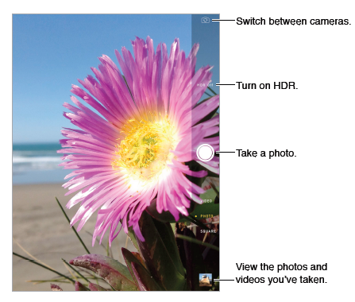
then tap .
- With iPad, you can take both still photos and videos using the front FaceTime camera or the back camera.

Take photos and videos
- Drag up or down to choose the Camera mode for still photos, square-format photos, or videos.
- Take a photo. Choose Photo, then tap the shutter button or press either volume button.
- Zoom in or out. Stretch or pinch the image on the screen. For some models, zoom is available in video mode as well as photo mode.
- Shoot some video. Choose Video, then tap the Shutter button or press either volume button to start and stop recording.
- Capture what’s displayed on your screen Simultaneously press and release the Sleep/Wake and Home buttons. The screenshot is added to your Camera Roll.
Take Burst shots:
(iPadAir2) Touch and hold the Take Picture button to take rapid-fire photos
in bursts (available while in Square or Photo mode). The shutter sound is different, and the
counter shows how many shots you’ve taken, until you lift your finger. To see the suggested
shots and select the photos you want to keep, tap the thumbnail, then tap Select. The gray
dot(s) mark the suggested photos. To copy a photo from the burst as a separate photo in your
Bursts album in Photos, tap the circle in the lower-right corner of the photo. To delete the
burst of photos, tap it, then tap

Exposure is automatic, but you can set the exposure manually for the next shot by tapping an
object or area on the screen. With an iSight camera, tapping the screen sets the focus and the
exposure, and face detection is temporarily turned off. To lock the exposure and focus, touch
and hold until the rectangle pulses. Take as many photos as you want. When you tap the screen
again, the automatic settings and face detection turn back on.
HDR
HDR (high dynamic range) helps you get great shots, even in high-contrast situations. The best parts of three quick shots, taken at different exposures (long, normal, and short), are blended together into a single photo.
- Use HDR. Tap HDR. For best results, keep both the camera and the subject still.
- Keep the normal photo in addition to the HDR version. Go to Settings > Photos and Camera.

Take a panorama photo.
(iSight camera in newer iPads) Choose Pano, tap the Take Picture button, then pan slowly
in the direction of the arrow. To pan in the other direction, first tap the arrow. To pan vertically, first
rotate iPad to landscape orientation. You can reverse the direction of a vertical pan, too

Choose Time-Lapse, set up iPad where you want, then tap the Record Time-Lapse Video button to start capturing a sunset, a flower opening, or other experiences over a period of time. Tap the Record Time-Lapse Video button again to stop. The time-lapse photos are compiled into a short video that you can watch and share.

Shoot some video.
Choose Video, then tap the Record Video button or press either volume button to start and stop recording. Video records at 30 fps (frames per second).
Take it slow. (iPadAir 2) Choose Slo-Mo to shoot slow motion video at 120 fps. You can set which
section to play back in slow-motion when you edit the video. Set the slow-motion section of a video. Tap the thumbnail, then use the vertical bars beneath the frame viewer to set the section you want to play back in slow motion

Camera settings
Go to Settings > Photos & Camera for camera options

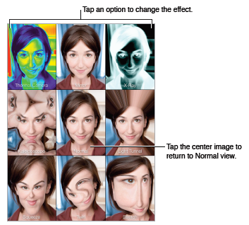
Photo Booth
Take a photo with Photo Booth and spice it up with effects.

- Select an effect. Tap , then tap the effect you want.
- Change a distortion effect: Drag your finger across the screen.
- Alter a distortion: Pinch, swipe, or rotate the image.
- To see results Tap the thumbnail of your last shot.
- To display the controls again, tap the screen.
- Switch between cameras. Tap at the bottom of the screen.

iMessage service
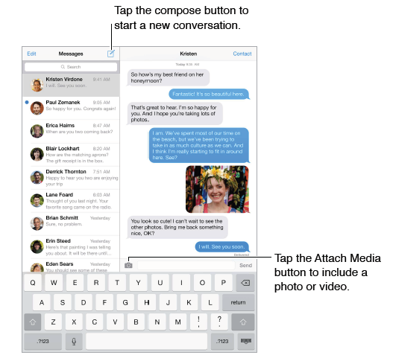
With the Messages app and the built-in iMessage service, you can send unlimited text messages over Wi-Fi using iOS 5 or later, or using OS X Mountain Lion or later. Messages can include photos, videos, and other info. You can see when people are typing, and let them know when you’ve read their messages. iMessages are displayed on all of your iOS devices logged in to the same account, so you can start a conversation on one device and continue it on another. For security, iMessages are encrypted before they’re sent.

Send and receive messages
- Start a text conversation. Tap , then enter a phone number or email address, or tap and choose a contact.
Note: Ain a conversation to try sending the message again.
- Resume a conversation. Tap the conversation in the Messages list.
- See what time a message was sent or received. Drag any bubble to the left.
- Make a FaceTime call to the person you’re texting. Tap Contact at the top of the screen, then tap .
- See earlier messages in the conversation. Tap the status bar to scroll to the top. Tap Load Earlier Messages, if necessary.
- Send messages to a group. Tap , then enter multiple recipients.

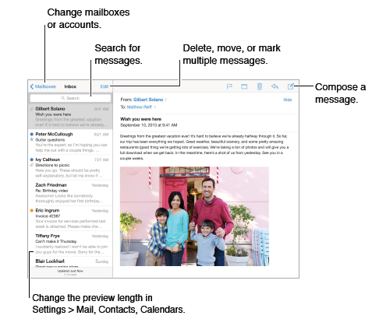
Mail
Write messages
- Insert a photo or video. Tap the insertion point, then tap Insert Photo or Video.
- Send a message from a different account. Tap the From field to choose an account.
- Finish a message later
- Save it, don’t send it. If you’re writing a message and want to finish it later, tap Cancel, then tap Save Draft.
- Finish a saved draft. Touch and hold Compose. Pick the draft from the list, then finish it up and send, or save it again as a draft.
- Show draft messages from all of your accounts. While viewing the Mailboxes list, tap Edit, tap Add Mailbox, then turn on the All Drafts mailbox.
- Delete a draft. In the Previous Drafts list, swipe left across a draft, then tap Delete.
- Search for a message. Scroll to or tap the top of the message list to reveal the search field. You can search the current mailbox, or all mailboxes at once. Searching looks at the address fields, the subject, and the message body.
- Attachments
  - Save a photo or video to your Camera Roll. Touch and hold the photo or video until a menu appears, then tap Camera Roll.
  - Use an attachment with another app. Touch and hold the attachment until a menu appears, then tap the app you want to open the attachment with.
  - Include attachments in your reply. When you reply to a message, attachments aren’t included. To include them, forward the message instead.
  - See messages with attachments. The Attachments mailbox shows messages with attachments from all accounts. To add it, view the Mailboxes list and tap Edit.
- Mail settings
  - Go to Settings > Mail, Contacts, Calendars, where you can:
  - Add mail accounts
  - Turn on Organize by Thread to group related messages together
  - Turn off confirmation for deleting a message
Music
iTunes Radio
Featured stations provide a great way to explore and enjoy new music in a variety of genres. You
can also create your own custom stations, based on your pick of artist, song, or genre.
Note: iTunes Radio may not be available in all areas.
- Get music and other audio content onto iPad:
- Purchase and download from the iTunes Store: In Music, tap Store.

FaceTime
Use FaceTime to make video or audio calls to other iOS devices or computers that support
FaceTime. The FaceTime camera lets you talk face-to-face; switch to the rear iSight camera to
share what you see around you.
Note: FaceTime may not be available in all areas. On iPad Wi-Fi + Cellular models, you can make
FaceTime calls over a cellular data connection.

- Make a FaceTime call. Make sure FaceTime is turned on in Settings > FaceTime, then in FaceTime, tap Contacts and choose a contact. Tap to make a video call, or tap to make an audio call.
- Use your voice to start the call. Press and hold the Home button, then say “FaceTime,” followed by the name of the person to call.
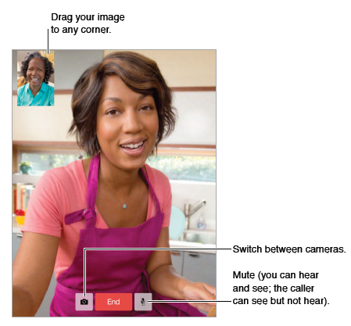
- Want to call again? Tap Recents, then choose a name or number.

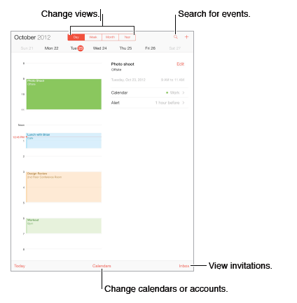
Calendar
- Search for events. Tap , then enter text in the search field.
- Change your view. Tap Day, Week, Month, or Year. Tap to view upcoming events as a list.
- Adjust an event. Touch and hold the event, then adjust the grab points, or drag it to a new time.
Calendar settings
There are several settings in Settings > Mail, Contacts, Calendars that affect Calendar and your calendar accounts. These include:
- Syncing of past events (future events are always synced)
- Alert tone played for new meeting invitations
- Default calendar for new events
Invitations
If you have an iCloud account, a Microsoft or Exchange account you can send and receive meeting invitations.
- Invite others to an event. Tap an event, tap Edit, then tap Invitees. Type names, or tap to pick people from Contacts.
- RSVP. Tap an event you’ve been invited to, or tap Inbox and tap an invitation. If you add comments (which may not be available for all calendars), your comments can be seen by the organizer but not by other attendees.
- Schedule a meeting without blocking your schedule. Tap the event, then tap Availability and tap “free.” If it’s an event you created, tap “Show As” and then tap “free.” The event stays on your calendar, but it doesn’t appear as busy to others who send you invitations.
Use multiple calendars
- Turn on iCloud, Google, Exchange, or Yahoo! calendars. Go to Settings > Mail, Contacts, Calendars, tap an account, then turn on Calendar.
- View Facebook events. Go to Settings > Facebook, then sign in to your Facebook account and turn on access to Calendar.
- See multiple calendars at once. Tap Calendars, then select the calendars you want to view.
- Move an event to another calendar. Tap the event, tap Edit, then select a calendar to move it to.
- You can subscribe to any calendar that uses the iCalendar (.ics) format. Supported calendar-based services include iCloud, Yahoo!, Google, and the Calendar application in OS X. You can read events from a subscribed calendar on iPad, but you can’t edit events or create new ones.
- Subscribe to a calendar. Go to Settings > Mail, Contacts, Calendars, then tap Add Account. Tap Other, then tap Add Subscribed Calendar. Enter the URL of the .ics file to subscribe to. You can also subscribe to an iCalendar (.ics) calendar by tapping a link to the calendar.
Share iCloud calendars
You can share an iCloud calendar with other iCloud users. When you share a calendar, others can see it, and you can let them add or change events. You can also share a read-only version that anyone can view.
- Create an iCloud calendar. Tap Calendars, tap Edit, then tap Add Calendar in the iCloud section.
- Share an iCloud calendar. Tap Calendars, tap Edit, then tap the iCloud calendar you want to share. Tap Add Person and enter a name, or tap to browse your Contacts. Those you invite receive an email invitation to join the calendar, but they need an iCloud account in order to accept.
- Change a person’s access to a shared calendar. Tap Calendars, tap Edit, tap the shared calendar, then tap the person. You can turn off their ability to edit the calendar, resend the invitation to join the calendar, or stop sharing the calendar with them.
- Turn off notifications for shared calendars. When someone modifies a shared calendar, you’re notified of the change. To turn off notifications for shared calendars, go to Settings > Mail, Contacts, Calendars > Shared Calendar Alerts.
- Share a read-only calendar with anyone. Tap Calendars, tap Edit, then tap the iCloud calendar you want to share. Turn on Public Calendar, then tap Share Link to copy or send the URL for the calendar. Anyone can use the URL to subscribe to your calendar using a compatible app, such as Calendar for iOS or OS X.

Contacts
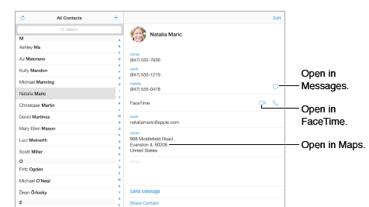
iPad lets you access and edit your contact lists from personal, business, and other accounts.
- Contacts settings
To change Contacts settings, go to Settings > Mail, Contacts, Calendars, Set your My Info card
- Set your My Info card for Safari, Siri, and other apps. Go to Settings > Mail, Contacts, Calendars, then tap My Info and select the contact card with your name and information.
- Let Siri know who’s who. While editing your My Info card, tap Add Related Name to define relationships you want Siri to know about.
- Find a contact. Use the search field at the top of the contacts list. You can also search your contacts using Spotlight Search
Videos at a glance
Open the Videos app to watch movies, TV shows, and music videos. To watch video podcasts,
install the free Podcasts app from the App Store. To watch videos you record using Camera on
iPad, open the Photos app.

Reminders 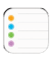lets you keep track of all the things you need to do.
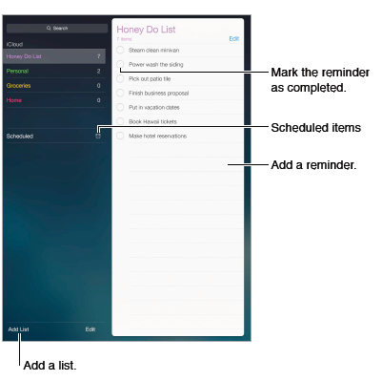
- Add a reminder. Tap a list, then tap a blank line. You can choose which of your Mail, Contacts, and Calendars accounts is used to save the reminder.
- Delete a list. While viewing a list, tap Edit, then tap Delete List.
- Delete a reminder. Swipe the reminder left, then tap Delete.
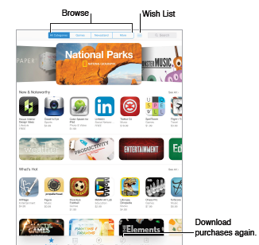
App Store at a glance
Use the App Store to browse, purchase, and download apps specifically designed for iPad, or for iPhone and iPod touch.
When you first open App Store, you’re prompted to download recommended free Apple apps,
including iBooks, iTunes U, Podcasts, Find My Friends, and Find My iPhone.

Purchase, redeem, and download
- Tap the app’s price (or tap Free), then tap Buy to purchase it. If it’s free, tap .
- Use a gift card or code. Tap Featured, scroll to the bottom, then tap Redeem.
- Delete an app. Touch and hold the app icon on the Home screen until the icon jiggles, then tap . When you finish, press the Home button. You can’t delete built-in apps. Deleting an app also deletes its data.
- You can download any app you’ve purchased on the App Store again, free of charge.

App Store settings
- To set options for App Store, go to Settings > iTunes & App Store. You can:
  - View or edit your account. Tap your Apple ID, then tap View Apple ID and log in. To change your password, tap the Apple ID field, then tap the Password field.
  - Sign in using a different Apple ID. Tap your account name, then tap Sign Out. Then enter the other Apple ID.
Turn off automatic downloads. Tap Apps in Automatic Downloads. Apps update automaticall

²³

