iOS Screen Recording Feature!

Screencasts are extremely helpful for learning how to use an app, find resources, or following step-by-step instructions. If you were an iPad user, this step involved a complicated set of instructions and wires. This is no longer the case!

You can now record screencasts and share from an iPad or iPhone. There is no special App to download because it comes native with iOS 11.

How does it work?
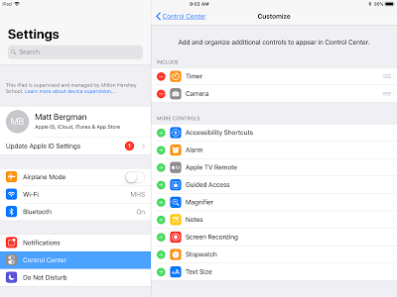

First, open up Settings and choose Control Center. You will see a listing of applications that you can use to add to your Control Center (when you swipe up on your device).

Then, you will need to tap on the green plus sign containing the "Screen Recording" option.

Next, swipe up on your screen or double click home button to access the Control Center and you will see an icon that looks like a white bullseye. Tap on this icon to begin recording.

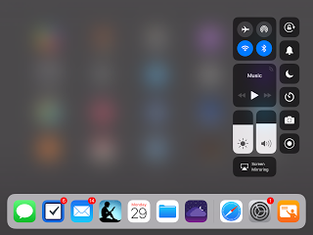

Finally, when you are finished, you will need to swipe up or double click home button again to access the control center. Tap on the bullseye icon again to stop your recording. Your video will convert into a video and save on your camera roll. Now you can share your video via text, email, Google Drive, etc.

Need to see this in action? Here is a screen recording:

