Innovation on display at tech show
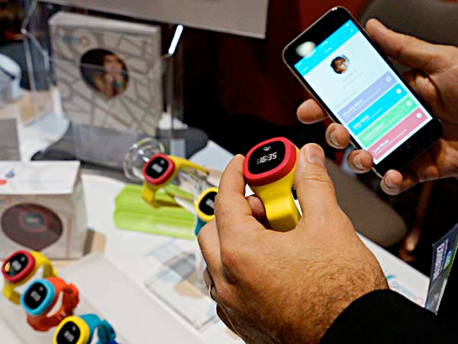
The hereO GPS watch for children and its accompanying mapping app are displayed at the International Consumer Electronics show (CES) in Las Vegas, Nevada January 4, 2015. According to the company, the hereO watch is the smallest GPS-tracking device available, engineered to fit a child's wrist.

Jeff Gelles, Inquirer Staff Writer Tuesday, January 6, 2015,

LAS VEGAS - Nearly eight years after Apple's first iPhone sparked a revolution in consumer technology, smartphones and increasingly ubiquitous sensors continue to dominate the innovation on display at the International Consumer Electronics Show, the massive event that begins here Tuesday and each year celebrates the next new things.

Want to kick a soccer ball better? The Adidas miCoach Smart Ball is embedded with sensors that track its speed, spin, and flight path from the moment you strike it - and then send the results to an iPhone.

Want to turn a brown thumb green? The Edyn Garden Sensor, promised later this year, uses sensors to monitor weather and soil conditions, and to direct its companion Edyn Water Valve to give your plants what they need. With a smartphone app, you'll be able to control the system from afar.

Want to track your baby's temperature - continuously? If the Food and Drug Administration approves, Blue Spark Technologies' Temp Traq will do that with a wearable patch - and your smartphone.

CES 2015: What to expect from the biggest tech show of the year

What trends are evident? One key development is that the spread of increasingly inexpensive sensors has furthered the "digitization of our physical space," fueling cycles of innovation that build and improve on what has come before.

Companies no longer simply focus on what is technologically possible, but on "what is technologically meaningful."

Adidas's award-winning soccer ball, for instance, follows a similar smart basketball, InfoMotion's 94Fifty, that scored big at CES 2014, as well as tools for teaching tennis, golf, and baseball swings from California's Zepp Labs, which introduced updated versions at Unveiled.

A different kind of refinement is behind another innovation shown at Unveiled: the Roost Smart Battery, which uses a clever twist to reduce the cost of remote smoke-alarm monitoring.

For years, consumers have been able to buy remotely monitored smoke and fire detectors as part of traditional alarm systems. In recent years, that capacity has become a popular feature in what the industry calls its "smart home" sector: systems that use cameras, motion sensors, electronic locks, thermostats, and similar devices to enable buyers to remotely control and monitor a variety of a home's systems.

Roost, founded in February in Sunnyvale, Calif., touts its battery - promised for shipment in May or June - as "a retrofit approach." Instead of buying a new, smart smoke detector, its customers will be offered a $30 replacement for the 9-volt batteries that typically power stand-alone detectors.

Inside the Smart Battery will be two lithium cells that will run the detector for about five years, and a WiFi chip that will connect it to a home network and a smartphone app. The battery can send an alert to the phone if an alarm sounds, and report when it needs replacing.

"No more annoying chirps," says Roost chief marketing officer David Henry. He calls the battery "a lower-cost solution" that can provide a measure of added safety to consumers who can't afford a smart home with all the bells and whistles.

Much of today's innovation cycle relates to Apple's iPhone introduction in 2007 and its decision a year later - perhaps spurred by competition from Google's Android - to allow outside developers to build apps for its platform.

As smartphones have proliferated - CEA says about two billion are now in use worldwide, surpassing personal computers - their prices have dropped, especially those of low-cost smartphones in the developing world. So have the prices of sensors they typically include, such as cameras and accelerometers, along with those of related technologies.

Those tools, along with increasingly sophisticated algorithms and user interfaces, offer enormous opportunity to the industry, says DuBravac, author of a book due for release next week titled Digital Destiny: How the New Age of Data Will Transform the Way We Work, Live, and Communicate. But he says using such tools effectively is often a matter of trial and error.

"We're in the experimentation period," DuBravac says, suggesting that a key question for any invention is: "Does it change the way we behave?"

Referring to one of last year's widely publicized and sometimes laughed-at inventions, Kolibree's "smart, connected toothbrush," DuBravac mused over how it might affect patients and doctors if someone outside a family knows whether and how well people follow their dentists' directions.

"It could be that every dentist becomes a data scientist," he says.

Of course, the Kolibree toothbrush is also an example of another feature of this annual show: what the industry calls "vaporware."

A PAGE 3bout 20,000 products are launched each year at CES, many of which fail. But some simply don't show up - or at least face long delays.

Kolibree won accolades last January for its connected toothbrush, promised by October. A year later, its website still offers preorders and says, "Coming soon."

